**Write the complete HTML+CSS code to build the webpage as shown below:**

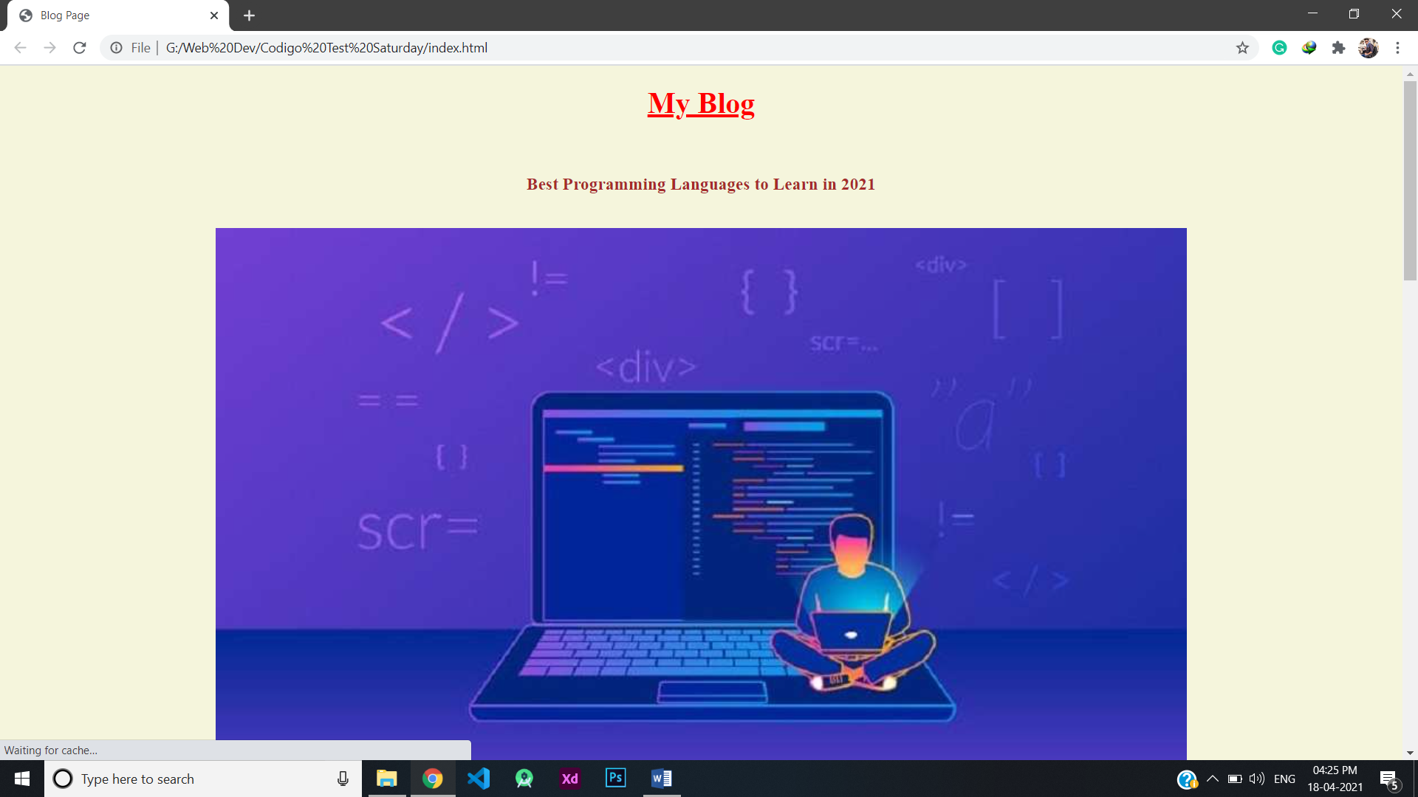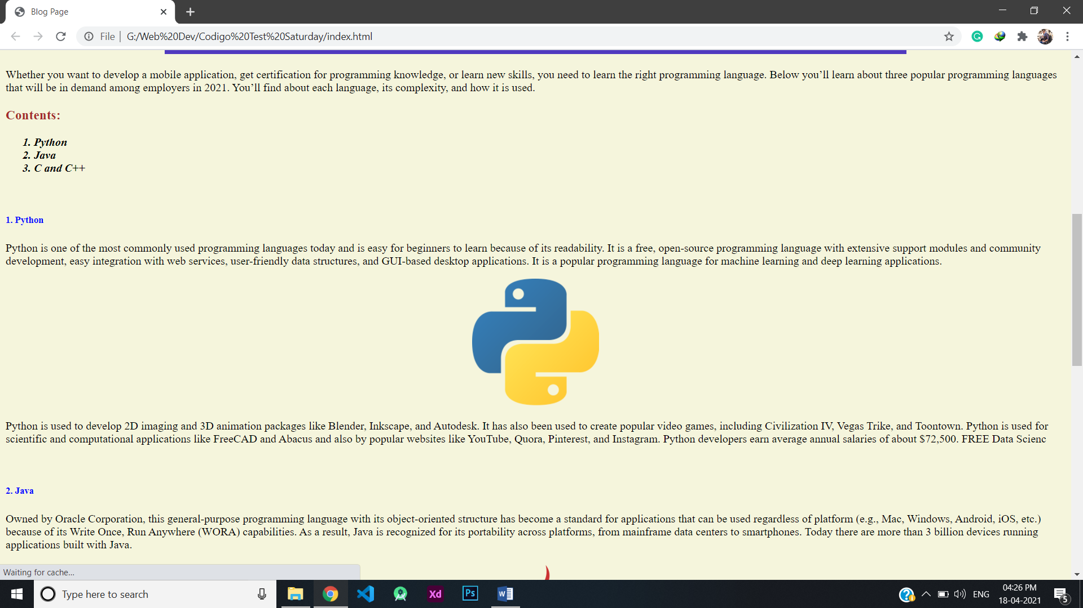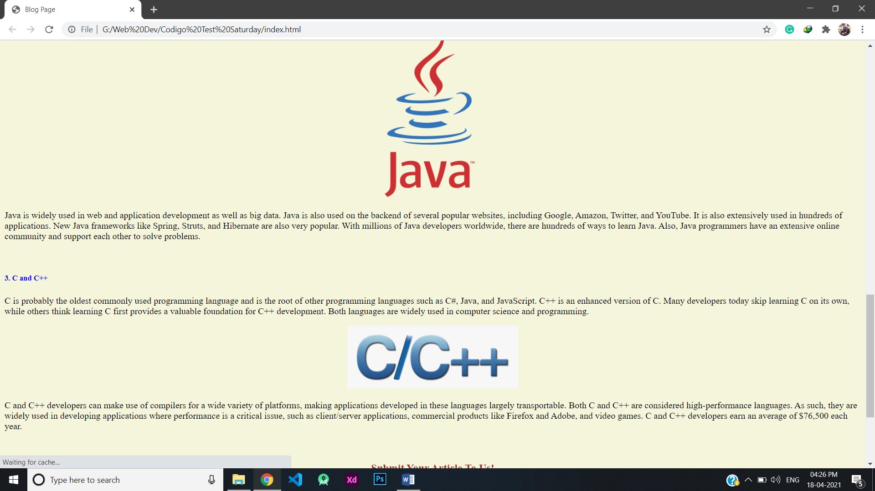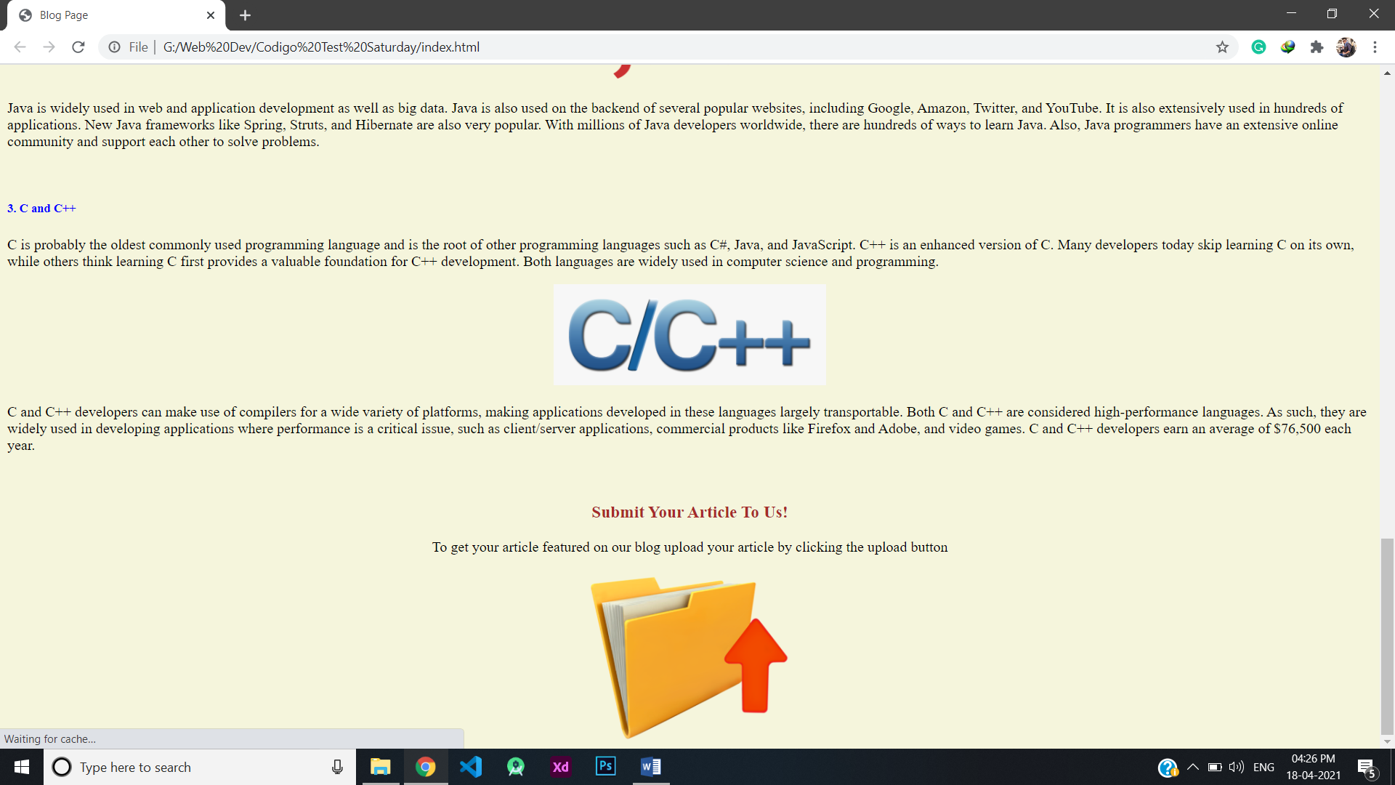

**Page Content and Layout**

**My Blog [h1, Red]**

Best Programming Languages to Learn in 2021 **[h3, brown]**

Image link: <https://content.techgig.com/thumb/msid-75430401,width-860,resizemode-4/5-tips-for-students-to-improve-coding-skills-during-college.jpg?58220> **[Width-70%]**

Whether you want to develop a mobile application, get certification for programming knowledge, or learn new skills, you need to learn the right programming language. Below you’ll learn about three popular programming languages that will be in demand among employers in 2021. You’ll find about each language, its complexity, and how it is used.

Contents: **[h3, brown]**

* ***Python***
* ***Java***
* ***C and C++***

**1. Python [h5, blue]**

Python is one of the most commonly used programming languages today and is easy for beginners to learn because of its readability. It is a free, open-source programming language with extensive support modules and community development, easy integration with web services, user-friendly data structures, and GUI-based desktop applications. It is a popular programming language for machine learning and deep learning applications.

Image link: <https://upload.wikimedia.org/wikipedia/commons/thumb/c/c3/Python-logo-notext.svg/768px-Python-logo-notext.svg.png> **[Width- 12%]**

Python is used to develop 2D imaging and 3D animation packages like Blender, Inkscape, and Autodesk. It has also been used to create popular video games, including Civilization IV, Vegas Trike, and Toontown. Python is used for scientific and computational applications like FreeCAD and Abacus and also by popular websites like YouTube, Quora, Pinterest, and Instagram. Python developers earn average annual salaries of about $72,500. FREE Data Scienc

**2. Java [h5, blue]**

Owned by Oracle Corporation, this general-purpose programming language with its object-oriented structure has become a standard for applications that can be used regardless of platform (e.g., Mac, Windows, Android, iOS, etc.) because of its Write Once, Run Anywhere (WORA) capabilities. As a result, Java is recognized for its portability across platforms, from mainframe data centers to smartphones. Today there are more than 3 billion devices running applications built with Java.

Image link: <https://www.probytes.net/wp-content/uploads/2019/07/java-logo-vector-768x768.png> **[Width-20%]**

Java is widely used in web and application development as well as big data. Java is also used on the backend of several popular websites, including Google, Amazon, Twitter, and YouTube. It is also extensively used in hundreds of applications. New Java frameworks like Spring, Struts, and Hibernate are also very popular. With millions of Java developers worldwide, there are hundreds of ways to learn Java. Also, Java programmers have an extensive online community and support each other to solve problems.

**3. C and C++ [h5, blue]**

C is probably the oldest commonly used programming language and is the root of other programming languages such as C#, Java, and JavaScript. C++ is an enhanced version of C. Many developers today skip learning C on its own, while others think learning C first provides a valuable foundation for C++ development. Both languages are widely used in computer science and programming.

Image link: <https://www.pngitem.com/pimgs/m/355-3559358_c-and-c-logo-hd-png-download.png> **[Width-20%]**

C and C++ developers can make use of compilers for a wide variety of platforms, making applications developed in these languages largely transportable. Both C and C++ are considered high-performance languages. As such, they are widely used in developing applications where performance is a critical issue, such as client/server applications, commercial products like Firefox and Adobe, and video games. C and C++ developers earn an average of $76,500 each year.

Submit Your Article To Us! **[h3, brown]**

To get your article featured on our blog upload your article by clicking the upload button

Image link: <https://blogs.sap.com/wp-content/uploads/2016/07/upload_989363.png>

**[Width-15%, The image should be within an Anchor Tag (put any link in the href)]**

**[Body Background Color-beige]**

**Send your answers to** [**siliconcodingclub@gmail.com**](mailto:siliconcodingclub@gmail.com)